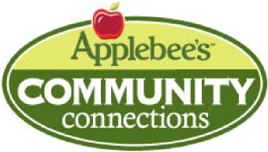

Flapjack
Fundraiser
Charity Guide

At Applebee’s, being part of the neighborhood is what we’re all about! We are happy to offer you the opportunity to raise funds and awareness for your organization by hosting a Flapjack Fundraiser at your local Applebee’s.

The basic premise of a Flapjack Fundraiser event is to offer our restaurant facility during non-operating hours to help you raise money by selling set breakfast plates. Following is a quick look at the responsibilities of each party.
Responsibility of Applebee’s
- Provide facility (location), kitchen and management staff.
- Provide plates, silverware and glasses.
- Order food/ingredients and prepare food.
- Make the event turn-key for organizations by supplying tickets and flyers for groups to copy and advertise.

Responsibility of Organization
- Advertise and promote the event utilizing tickets and flyer provided by Applebee’s.
- Provide volunteers to greet, seat, serve and clean up.
- Print and sell tickets (recommended selling price is $10 - $15 per ticket)

Additional details regarding the specifics of the event are included on the following pages. If you are interested in hosting an event, please visit www.flapjackfunds.com to reserve a date. After reserving the date, a manager will call you to confirm your booking. The manager will answer any outstanding questions you might have.

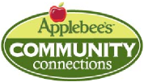
Flapjack Fundraiser
Charity Guide

Several frequently asked questions are below to help you plan for and organize your fundraiser. Should you have any questions at anytime, please visit www.flapjackfunds.com or reach out to your local Applebee’s manager for guidance on how to best prepare for your event. We look forward to working with you to make your fundraiser a success!

Planning

What are the available times to have the fundraiser?
- Flapjack Fundraisers are scheduled on Saturday or Sunday mornings between 8:00 a.m. and 10:00 a.m.
- Date availability is limited so please book early.
- Calendars on www.flapjackfunds.com provide you open date opportunities.

What information do I need to supply Applebee’s?
- Organization name and address.
- Primary contact name, phone number and email.
- Date and time of the event.
- Number of volunteers available (minimum of seventeen people; volunteers must be at least sixteen years old).
- A $100 check to hold as a deposit for your event date
- Tax ID number and identification form (if a nonprofit organization)

Can I conduct other activities during the fundraiser like face painting, raffle tickets or a car wash to raise extra money?
- We are happy to accommodate most ideas. Please talk to the manager as optional activities are at his/her discretion. If permitted, all extracurricular activities must be completely organized and conducted by the organization. Unfortunately we cannot allow any ancillary sales during the time of the event such as sales of products/services e.g. makeup, jewelry, baked goods.

What is served at the breakfast?
- Pancakes, sausage, scrambled eggs and a beverage choice including coffee, juice, soda and tea.

How many tickets can we sell?
- No more than 300 tickets can be sold for an event in order to ensure timely execution and that everyone is served between 8am – 10am.
- We require a $100 deposit to hold your set fundraiser date
- A minimum 100 tickets sold to host an event for your organization. (Minimum due to Applebee’s day of event $500)
- 100 tickets x $6.00 = $600.00 – the $100 deposit = $500 minimum)

How much should we charge?
- Although this is completely up to your organization the recommended price for a Flapjack Fundraiser ticket is $10 - $15.
- Remember Applebee’s requires that $6.00, plus applicable sales tax, from the sale of each redeemed ticket be provided back to the restaurant. Please check with the General Manager of the location of your Flapjack to confirm tax rate and amount. All organizations will be charged sales tax, unless a valid tax exemption document is provided.

When should we start selling tickets?
- Groups should plan at least three to four weeks prior to their event to sell tickets to ensure a successful event.

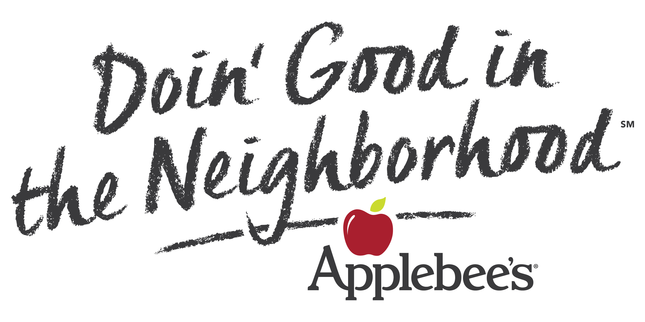
Flapjack Fundraiser
Charity Guide

FAQ’s (continued)
Where do we order the tickets and other advertising supplies?
- After booking a time on www.flapjackfunds.com and giving your event deposit to the Applebee’s manager, you will receive a confirmation email with a unique username and password. Use this username and password on www.flapjackfunds.com to download your flyers and tickets.
- Often times, local newspapers will run an ad to support community events. Be sure to provide your local newspapers with a press release of your event.
- Remember to take photos at the event and to send a post-event recap to the newspaper including the total funds collected and thanking guests for their support.
Volunteers
How many volunteers do we need to help host the event?
- The organization is responsible for the service staff including hosts, servers and bussers.
- Applebee’s will supply kitchen staff.
- Volunteers must be at least sixteen years old and will be required to sign a release of liability the morning of the event.
- Here is an estimated number of volunteers needed based on ticket sales. Please contact Applebee’s two weeks prior to and one week prior to your event to provide an update on tickets sold.
# of  Tickets Sold | Volunteers Needed
# of  Tickets Sold | Seaters/Greeters | Pancake Servers | Beverage Servers | Bussers | TOTAL
100-150 | 3 | 7 | 4 | 3 | 17
151-200 | 3 | 7 | 5 | 3 | 18
201-250 | 4 | 7 | 5 | 3 | 19
251-300 | 4 | 8 | 5 | 4 | 21
Do we need to give the volunteers any special instructions?
- Plan to arrive thirty minutes early the day of your event. Your Applebee’s manager will give the volunteers a quick tour of the restaurant and explain a few pointers for hosting, seating and serving guests.
- Most importantly, your volunteers should relax and have fun while welcoming and thanking the guests for their support.
- Depending upon your type of organization encourage your group to wear coordinating t-shirts or uniforms so guests can easily identify the volunteers.
Accounting
- Please bring a check with you to the event. Following the event, your group contact and the Applebee’s manager will determine the total number of guests. Your group is responsible for $6.00, plus applicable sales tax, per guest in attendance. If volunteers are going to eat breakfast you will also be responsible for their meals as well. The amount that you decide to charge to the volunteers will once again be up to you.
Event Day Reminders
- Tickets can be sold at the door as we do accept walk in guests.
- Be sure the host has extra tickets on hand.
- If your group has a cash box please bring it as one will not be provided to you, to keep your funds safe.
- Your organization is responsible for supplying change if need be for guests that pay morning of.
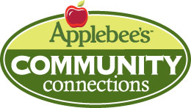
Program Overview

Applebee’s Contact Person:_____________________________________

Restaurant Phone:_________________________ Date of Event:_________________________

Flapjack Fundraisers are conducted during non-business hours on Saturday or Sunday mornings from 8:00 a.m. to 10:00 a.m. based on restaurant manager approval.
Your organization sells a maximum of 300 tickets (100 minimum) & provides volunteers to work at the function. Your group will keep all ticket sales revenue minus $6.00 per attendee, plus applicable sales tax.
The recommended price for a Flapjack Fundraiser ticket is $10 - $15. Remember Applebee’s requires $6.00, plus applicable sales tax, from the sale of each redeemed ticket be provided back to the restaurant. All organizations will be charged sales tax, unless a valid tax exemption document is provided. This charge will need to be paid the day of the event at the conclusion of the event.
Each breakfast consists of 3 pancakes, 2 pieces of sausage, scrambled eggs and beverages including coffee, juice, soda and tea.
Action Items - After Booking Your Event Date

Pre-Event | 4-5 weeks before event:  - Book your event on www.flapjackfunds.com .  - Deposit check to Applebee’s manager.  - Review and print ticket and flyers.  - Distribute tickets to organization members to sell.  3-4 weeks before event:  - Begin selling tickets. Sell tickets to friends, family members…anyone supporting your organization!  - Determine number of volunteers needed, depending on size of event (refer to volunteer matrix).  - Assign volunteers to each position:  - Greeter: Greet guests as they arrive  - Seater: Seat guests and manage wait list (if applicable)  - Pancake Server: Serve pancakes from kitchen  - Beverage Server: Serve beverages (coffee, soda, juice)  - Busser: Clear dishes and clean table  1 week before event:  - Confirm number of tickets sold with manager.  - Confirm number of volunteers with manager.
Event Day | Morning of event:  - Volunteers arrive at 7:30 a.m., park in rear of restaurant and enter through front door.  - Volunteers must sign a wavier form before event begins  - Proper dress:  - Pants or shorts (no more than 2 inches above the knee)  - Non-slip shoes  - Moderate jewelry  - Hair – washed and groomed (if longer than collar length, must be tied back)  General Rules:  - For safety reasons, no one except volunteers will be allowed in kitchen. Volunteers are not allowed behind the cook’s line.  - If you are ill, do not plan to work.  - Food from outside the restaurant is not allowed.  7:30 a.m.  - • Meet manager at front door.  • Attend Flapjack Fundraiser training.

